**DP Lecture 6**

**1D – DP**

**House Robber**

**Problem Statement:**Dynamic Programming: House Robber (DP 6)

*Problem Statement Link:*[*House Robber*](https://www.codingninjas.com/codestudio/problems/house-robber_839733?source=youtube&campaign=striver_dp_videos&utm_source=youtube&utm_medium=affiliate&utm_campaign=striver_dp_videos)

A thief needs to rob money in a street. The houses in the street are arranged in a circular manner. Therefore, the first and the last house are adjacent to each other. The security system in the street is such that if adjacent houses are robbed, the police will get notified.

Given an array of integers “Arr” which represents money at each house, we need to return the maximum amount of money that the thief can rob without alerting the police.

**Examples:**

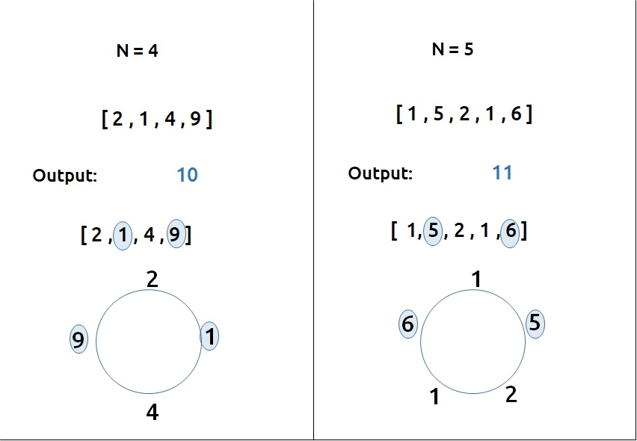

**Pre-req:**[**Maximum Sum of non-adjacent elements**](https://takeuforward.org/data-structure/maximum-sum-of-non-adjacent-elements-dp-5/)

**Solution :**

This question can be solved using the approach discussed in the [Maximum Sum of non-adjacent elements](https://takeuforward.org/data-structure/maximum-sum-of-non-adjacent-elements-dp-5/). Readers are highly advised to go through that article first and then read this. The rest of the article will refer to the previous article as Article DP5 and will relate to that approach.

Now, we have a single test case. Three houses have money as shown.

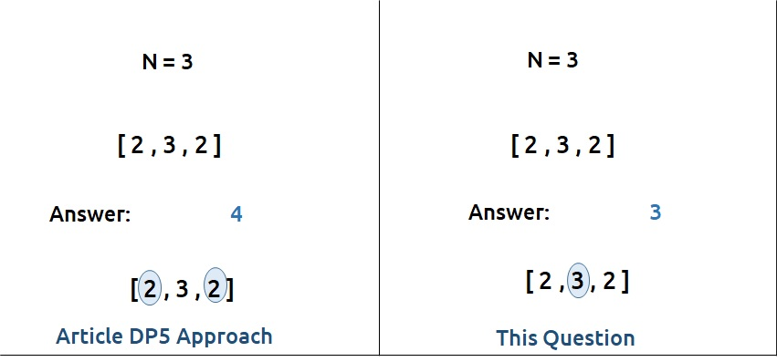

* According to article DP5, the answer will be 4(2+2) as we are taking the maximum sum of non-adjacent elements.
* In this question, the first and last element are also adjacent (circular street), therefore the answer will be 3.

**Modification to Article DP5’s Approach**

We were finding the maximum sum of non-adjacent elements in the previous questions. For a circular street, the first and last house are adjacent, therefore one thing we know for sure is that the answer will not consider the first and last element simultaneously (as they are adjacent).

Now building on the article DP5, we can say that maybe the last element is not considered in the answer. In that case, we can consider the first element. Let’s call this answer ans1. Hence, we have reduced our array (arr- last element), say arr1, and found ans1 on it by using the article DP5 approach.

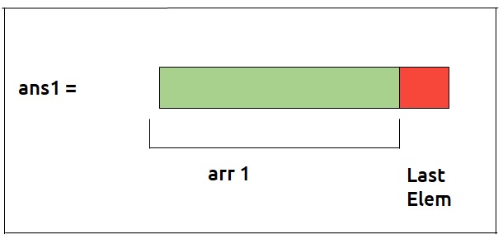

Now, it can also happen that the final answer does consider the last element. If we consider the last element, we can’t consider the first element (again adjacent elements). We again use the same approach on our reduced array (arr – first element), say arr2. Let’s call the answer we get as ans2.

Now, the final answer can be either ans1 or ans2. As we have to return the maximum money robbed by the robber, we will return max (ans1, ans2) as our final answer.

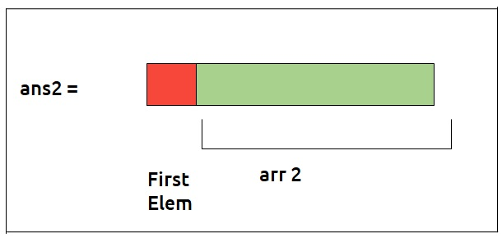

**Space Optimization**

The approach to solving this problem can be summarized as:

* Make two reduced arrays – arr1 (arr - last element) and arr2 (arr - first element).
* Find the maximum of non-adjacent elements using Space Optimization Solution as mentioned in article DP5 on arr1 and arr2 separately. Let’s call the answers we got as ans1 and ans2 respectively.
* Return max (ans1, ans2) as our final answer.

**Code:**

#include<bits/stdc++.h>

using namespace std;

int maximumNonAdjacentSum(vector<int>& *arr*) {

    int n = arr.size();

    int prev2 = 0, prev = arr[0];

    for (int ind = 1; ind < n; ind++)

    {

        int pick = arr[ind];

        if(ind > 1) pick += prev2;

        int notPick = 0 + prev;

        int cur = max(pick, notPick);

        prev2 = prev;

        prev = cur;

    }

    return prev;

}

int main(){

    vector<int> valueInHouse{2, 3, 2};

    int len = valueInHouse.size();

    if(len == 1) {

        cout<<"Ans : "<<valueInHouse[0];

    }

    else {

*// temp1 --> Contains all the elements of 'valueInHouse' except first element*

*// temp2 --> Contains all the elements of 'valueInHouse' except last element*

        vector<int> temp1, temp2;

        for (int i = 0; i < len; i++)

        {

            if(i != 0) temp1.push_back(valueInHouse[i]);

            if(i != len-1) temp2.push_back(valueInHouse[i]);

        }

        cout<<"Ans : "<<max(maximumNonAdjacentSum(temp1), maximumNonAdjacentSum(temp2));

    }

    return 0;

}

**Output:** 11

**Time Complexity: O(N)**

Reason: We are running a simple iterative loop, two times. Therefore, total time complexity will be O(N) + O(N) ≈ O(N)

**Space Complexity: O(1)**

Reason: We are not using extra space.